SoMa Decking Deterioration Claims

SoMa rowhouse homeowners, particularly in Phases 1 2, and 3, have reported significant deterioration in the decking on their balconies and roofs.

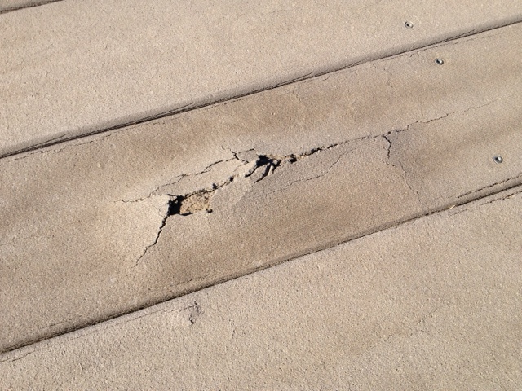

If the deteriorating decking at your unit is determined to be a particular decking manufactured by Louisiana Pacific Corporation (LP) prior to October 29, 2007 then you may be able to have the decking replaced free of charge pursuant to the terms of a Settlement Agreement dated September 23, 2010. The Settlement Agreement was entered into as a result of a class action lawsuit against LP.

In order to make a claim under the Settlement Agreement, a SoMa homeowner must establish that the decking material on his/her unit is covered by the terms of the Settlement Agreement—i.e. manufactured by LP at one of the two plants before the specified date.

At least three SoMa homeowners have successfully made claims over the last year or so under the Settlement Agreement. If you have deterioration of your decking and decide that you would like to pursue a claim here are a few tips--

1. Go to www.lpdeckingclass.com for instructions on how to make a claim. The site contains a copy of the Settlement Agreement and claim forms and an FAQ section.

2. The Settlement Agreement prohibits the “bundling” of claims. Each homeowner that is interested in making a claim must fill out a claim form and make separate application as specified in the Settlement Agreement.

3. Under the claim form you will be required to provide evidence of make, model (LP Weatherbest driftwood gray) and installation date of the decking material. Ron Wellendorf of Builders Supply Company (they installed the original decks) has written a letter for at least one homeowner evidencing these matters. Builders Supply’s phone number is 402-331-4500. Lund Ross has also furnished such a letter—the main number for Lund Ross is 402-342-2810. Ask for Scott Thompson, the project manager for SoMa.

4. Another way to establish your installation date for purposes of the claim is to order a certificate of occupancy from the County for $7.50. Go to permit.info@ci.omaha.ne.us, or call Richard Hawthorne at 402-444-5360

5. You will be asked to submit evidence of your ownership of the unit and that can be done with a copy of your Real Estate Tax Statement, which reflects your name and the address of your unit.

6. For proof of damage you can take photos of the damaged areas and attach them to the claim form. Take photos from the roof deck and the balcony deck if you have a claim for both areas.

7. If you are asked to establish that you are responsible for maintenance of the deck (you are) rather than the HA, you should send a copy of page 9 of the Declaration of Easements, Covenants and Restrictions dated April 15, 2005. This is the HA’s governing document and the document we refer to when we talk about “the Declaration”.

8. If the claim is judged to be sufficient on its face, a contractor will call you to schedule an inspection of your deck. This can be as soon as one month after filing the claim.

9. If your claim is approved, you will get a letter so stating. This can occur as soon as one month after the inspection.

10. After approval, you will be contacted by the company that will replace your decking, and you will discuss scheduling and logistics. Plan on a full day for tear out and a full day for installation. Make sure that you ask for a crane to get the materials to the roof—bringing materials up the stairs in your unit is not practical.

11. Expect the new decking boards to be gapped wider than the original decking. This increases airflow and keeps the temperature down to help prevent deterioration.

12. Be patient with the process. One homeowner didn’t get through the process and have the deck replaced until nine months after a claim was filed.

SoMa Homeowners Association (January 9, 2012)

